Multi-Scale Modeling for Water Resources Planning and Management in Rural Basins

Flávio B. Victoria, João S. Viegas Filho, Luis S. Pereira, José L. Teixeira³,
A. Eduardo Lanna

Abstract
This study aims at adopting modeling tools focusing multi-scale problem solving in basins with irrigation water uses. Multi-scaling may help conflict solving since an approach to the scale close to that where conflicts occur is more appropriate for understanding and dealing with related problems. It mainly applies to rural basins where competition among agricultural and non-agricultural uses is high during periods when water availability is scarce. The approach refers to the field scale modeling relative to agricultural demand considering soils, crops and crop patterns, cropping techniques, environment factors, irrigation practices and restrictions to water use (ISAREG model), and basin scale water resource planning models including non-agricultural uses – urban, domestic, industrial, recreational and other uses (SAGBAH model). Analyses of scenarios require then a multi-scale approach. It results a tool that produces a distributed spatial analysis of the agricultural demand, while non-agricultural uses refer to sub-basins. Simplicity in model operation is aimed. The model operates interactively, sharing results from the sub-models, in order to obtain the information required to define strategies for crop irrigation management and to assess impacts on the non-agricultural users, and to generate rules for water allocation in the basin. The multi-scale analyses allows to improve knowledge on the processes relative to water use, to understand spatial and temporal variations, to simulate with historical data and for different scenarios, including those that may result from climate change. First results of this approach are included in this paper.
Keywords: Water resources management, multi-scaling integration, demand simulation, irrigation, non-agricultural water users.
1. INTRODUCTION
A river basin system is of great complexity due to the large number and diverse nature of its components and the dynamic interaction among them. On the one hand, the hydrologic cycle is basically dependent upon the geology and the climate, which determine the physical characteristics of the basin, the natural environment, and the variability of the mass and energy exchanges occurring within the basin. On the other hand, human activities impact on the natural resources, mainly through land and water use, and produce changes in the dynamics of the natural environment and the hydrological cycle, which may amplify the variability of those exchanges, affecting the hydrologic balance and the use of the natural resources. The decision making processes that ensure the sustainable use of the natural resources and the balanced development of human activities are main challenges to the society, particularly when water is scarce (Pereira et al., 2002a).
In river basins where agriculture is the dominant activity, the farmers’ responsibility embraces the good use of land, water and energy natural resources, the preservation of the nature and the conservation of the resources and the environment (Pereira et al., 2002b). However, farmers generally act isolated, without appropriate support by the society, using empirical knowledge and facing challenging contradictory market forces and environmental pressures. Appropriate methodologies relative to technical assessment and analysis are required to enhance knowledge and provide for tools applicable by farmers, technical staff, the public administration and other decision and policy makers (Perry and Narayanamurthy, 1998; Rosegrand et al., 2001; CGIAR, 2002). Such methodologies may contribute to implement adequate measures for river basins management, sustainable use of resources, and regional development by considering present and future requirements for human activities, the natural environment, and the quality of life. Those have to be based upon improved knowledge of the processes and the feasibility of planned issues in such a way that economical activities, environment conservation, and related reduction of risk and vulnerability are effective. This implies that alternative scenarios be considered and evaluated taking into account the mutual interactions and impacts of activities, technologies and processes of diverse nature including land use, water withdrawals, deforestation, agricultural intensification, urban development, environmental changes and climate changes (Molden et al., 2001; CGIAR, 2002; UNEP, 2002). An example for multi-criteria analysis relative to irrigation water demand at scale of a large project aiming at water saving is presented by Gonçalves et al. (2002).
The use of models aims at better taking into consideration the complexity of natural processes and the interdependence of impacts resulting from man activities and attitudes (Viegas Filho and Lanna, 1999; Viegas Filho, 2000). Models are developed aiming at representing the reality at different time and space scales and have objectives both relatively general and focusing specific problems and the related issues. Responses from models are often more accurate when their application is well focused and the time and space scales are small, e.g. ISAREG model for irrigation management (Liu et al., 1998). However, responses are often required at a large scale, as it is the case for river basin planning and management, which requires the understanding of multiple processes including those relative to water demand and use, surface and groundwater availability, and the impacts on the water cycle and balance (Seckler et al., 1998; Strzepek et al., 2001). Up-scaling using geographic information systems (GIS) may be a solution when using a field model to compute regional irrigation requirements (e.g. Fortes et al., 2004) but this may be not sufficient when the agricultural water demand is in competition with non-agricultural uses and water resources planning and management at basin scale has to make compatible the irrigation demand at local scale with other demands within the basin (Lanna, 1997b; Pilar and Lanna, 1999). Multi-scale approaches are then required.
Research developed at the Research Centre CEPAF/EPAGRI in S. Catarina State, Brazil, have shown that it is important to systematically focus the irrigation water use activities in relation to the water cycle and balance at the basin scale and using multidisciplinary approaches (Victoria, 1998; Victoria and Teixeira, 2001). It results the need to use together focused models referring to different subjects, which may be useful for decision making in agriculture and other economic activities. However, such discipline oriented models have serious limitations in being explored interactively because the time and space scales are different and not compatible, as it is the case of ISAREG for irrigation management at the field scale (Teixeira and Pereira, 1992) relative to the model package SAGBAH for basin water management (Lanna, 1997a). Furthermore, the ever growing competition among water uses, the importance of water for domestic uses and economic activities, as well as the need of water for the natural environment require decision tools that can not rely on simple regional or national averages. On the contrary, those tools have to base upon a dynamic knowledge base that effectively represent local conditions, aims and constraints.
A great potential exists to produce that relevant information for decision makers when the interaction among models at different scales enable the illustration of irrigation requirements by small farmers in competition with those of the rural and urban settlings and the industry within the basin. Decision-making may be improved by adopting up- and down-scaling procedures that facilitate the interactive use of models. Eventual conflicts may then be better solved.
The great and often chaotic urban growth into agricultural and fertile areas associated with the increased need for food for an ever growing population may require that irrigated agriculture develop in areas where yields may be increased due to controlling the risk associated with rainfall and climate variations. However, this requires that water be used more efficiently and water and energy wastes be avoided. Thus, environmental friendliness and technologies to cope with water scarcity, climate change or other man made impacts have to be considered (The World Bank, 2003; UNEP, 2002; Molden et al., 2001, Pereira et al., 2002a). To use water more rationally is a must mainly when we know that using appropriate technologies it is possible to improve water productivity and control water wastes (Rosegrand et al, 2001; FAO, 2002; Pereira, 2003). Modern technologies allow a systemic but holistic approach considering the complexity of rainfall and runoff events and the multiple types of water demand for different uses, including paying more attention to the processes determining the agricultural demand, which consumptive water uses are the highest (CGIAR, 2002). With exception of the areas where rainfall is regular and well distributed along the crop season, irrigation is required to supply the ever-growing demand for food, either for the entire crop season or to supplement rainfall, mainly to avoid the risks associated with rainfall variability. Nevertheless, an appropriate selection of crop patterns, crop and soil management practices and irrigation practices are required for water conservation and saving (Perry and Narayanamurthy, 1998; Pereira et al, 2002a). Modeling is helpful to support irrigation management decisions that take into account the environmental requirements, particularly when both basin scale water resource planning and management and field scale irrigation simulation models are used interactively. This allows that decisions be taken based upon the understanding of the complexity of physical, economic and social processes.
The objectives of the present research are to develop an approach that provides for the integration of the field scale irrigation scheduling simulation model ISAREG (Teixeira and Pereira, 1992, Pereira et al., 2003) with the basin scale model package SAGBAH for basin water management (Lanna, 1997a), particularly its water yield propagation model PROPAGAR (Viegas Filho, 2000), aiming at creating a more powerful decision support tool for planning water allocations in river basins where irrigation is competing with other uses. The resulting model should be able to produce irrigation scheduling and management options at field scale that are compatible with decisions relative to the river basin water management and, simultaneously, basin scale decisions take into consideration the field scale irrigation management options. The study is applied to the S. José River basin, S. Catarina, Brazil, located in the western region of the State(Fig. 1).

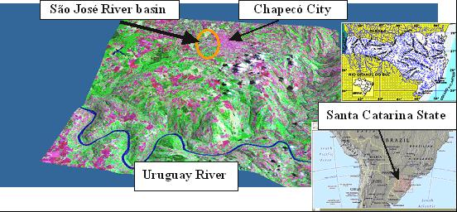

Fig. 1. Location of S. José River basin, Chapecó, Santa Catarina, South Brazil.

2. MODELING
2.1. Models ISAREG and PROPAGAR
The ISAREG is a soil water balance simulation model aimed at establishing irrigation scheduling programs for a given soil-climate-crop combination (Teixeira and Pereira, 1992; Liu et al. 1998; Pereira et al., 2003). The model applies to the field scale. Simulations can be performed for a single crop or for a succession of up to three crops. The model ISAREG is combined with two other computer programs, EVAP56 that computes the reference evapotranspiration, ET_{o}, using the FAO Penman-Monteith method (Allen et al., 1998), and KCISA for computing the required crop parameters using the updated FAO methodology for calculating crop evapotranspiration, ET_{c} (Allen et al., 1998). Computations can be performed for daily, 10-day or monthly time steps. The model can be used under different alternative options:
- To schedule irrigations aiming at maximum yields. Simulations are performed using a soil water threshold selected to avoid water stress of the crop;
- To simulate an irrigation schedule adopting user selected forms to compute the application depths and the irrigation thresholds, including under water supply constraints dictated by basin water availability and allocation policies.
- To evaluate an irrigation schedule when irrigation frequency and depths are pre-determined or known from the field.
- To execute the water balance without irrigation, and
- To compute the net irrigation water requirements and performing a frequency analysis when historical data sets are used.
To support users decisions for selecting the most appropriate schedule, the model uses a simplified linear relationship between the relative yield loss and the relative seasonal evapotranspiration deficit as proposed by Stewart et al. (1977) and Doorenbos and Kassam (1979) using a crop specific yield response factor K_{y}.
The soil water balance is performed for the complete effective rooting depth as:

θ_{i} =θ_{i-1} + (P_{i} – Q_{r i} + I_{n i} – ET_{a i} – DP_{i} + GW_{i}) / (1000 z_{r i}) (1)

where
θ_{i} average soil water content in the root zone on day i [mm mm⁻¹],
θ_{i-1} soil water content on the previous day [mm mm⁻¹],
P_{i} precipitation on day i [mm],
Q_{r} _{i} runoff from the soil surface on day i [mm],
I_{n} _{i} net irrigation depth on day i [mm] (irrigation water infiltrating the soil),
ET_{a} _{i} actual crop evapotranspiration on day i [mm],
DP_{i} deep percolation on day i [mm],
GW_{i} upward flux of water from a shallow water table on day i [mm], and
z_{r} _{i} root depth on day i [m].
The model computes θ_{i} and then calculates the required irrigation depths I_{n i} when the selected soil water thresholds are reached. The θ_{i} value at the first day of simulation is an input parameter. The ET_{a} computations base on the calculation of the crop evapotranspiration using the crop coefficient approach (ET_{c} = K_{c} ET_{o}), with ET_{a} = ET_{c} when the soil water is above the threshold θ_{p} relative to the p depletion fraction for no-stress (Allen et al., 1998), or ET_{a} < ET_{c} in proportion to the soil water deficit (θ_{p}-θ_{i}) as described by Liu et al.(1998). The model empirically estimates the groundwater contribution, GW_{i}, and deep percolation, DP_{i} (Pereira et al., 2003). The runoff depth Q_{r i} can be predicted using the SCS curve number method (SCS, 1982) but, for most applications, it is computed by the model as a part of the non-used precipitation.
The ISAREG model has been used in several locations, such as China (Liu et al., 1998) and the Mediterranean, both for field crops (Rodrigues et al., 2003, Zairi et al., 2003) and orchards (Alba et al., 2003). Data input mainly consists of weather data used to compute ET_{o} and the crop coefficients (K_{c}), crop data relative to the crop growth stages and root depths, and soil data referring to soil water contents at field capacity and wilting point for a multi-layered soil. Additional data refers to periods where water availability restrictions apply and soil and groundwater characteristics influencing capillarity and percolation.
The PROPAGAR model is part of the software package SAGBAH aimed at supporting management and water allocation at river basin scale. It uses object oriented software language (Lanna, 1997a; Viegas Filho, 2000). PROPAGAR simulates the time and space variation of discharges in selected nodes of the river system, where simulated discharges result from the natural ones as modified by the demand for every use. Therefore, for each node or control point (PC) and time interval, the model performs the balance between the inflow discharges and the demands at that location and estimates the outflows into the downstream reaches. Computations are made for several time steps.
The water balance at a PC with a reservoir may be expressed as

S (t+1) = S (t) + Q (t) - D (t) + R [D(t)] – X (t) – E [S(t+1),S(t)] (2)

where:
S (t) reservoir storage at beginning of the time interval t [m³];
S (t+1) reservoir storage at end of the time interval t [m³];
Q (t) inflow discharge [m³ s⁻¹], sum of the water yield produced in the watersheds located up to the next upstream PC and the net outflow discharges from that PC;
D (t) total demand to be supplied at that PC [m³ s⁻¹];
R [D(t)] return flow corresponding to the satisfied demand [m³ s⁻¹]
X (t) outflow discharge [m³ s⁻¹] both to run in the river to the next PC and to satisfy various demands located downstream but controlled from the reservoir.
E [t] reservoir evaporation during the same time interval [m³];

When there is no reservoir in the PC the water balance equation simplifies as:

X (t) = Q (t) – D (t) + R [D(t)] (3)

Using historical data sets, observed or estimated from hydrological rainfall-runoff modeling, rainfall and ET data sets relative to the same periods, and the typology data characterizing the demand for different users along the river reaches, the model allows assessing the conditions for satisfaction of the demands for various uses.
PROPAGAR and SAGBAH have been used in several river basins in Brazil to support water resources allocation planning and management. Because PROPAGAR adopts the object-oriented language, it easily simulates changes in the configuration of the demand along the basin and the impacts of regulation reservoirs located along the basin, or analyses the need for regulation reservoirs to be built in the basin.
2.2. Multi-scale model integration
PROPAGAR simulates well the water demand for domestic and industrial uses, including agro-industry, as well as for energy generation and maintenance of ecological discharges in downstream reaches. However, it has limitations concerning irrigation due to the seasonality of these uses and its dependence on the rainfall and ET variation along the year and from a year to the next. Therefore, coupling ISAREG with PROPAGAR gives much more powerful conditions to consider the irrigation requirements for any agricultural area inside the basin. The integration of models to produce multi-scale water management is represented in Fig. 2.

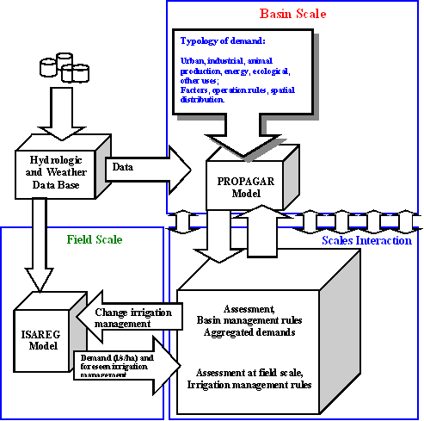
Fig. 2. Scheme on the integration field scale – basin scale.

To allow the operation of both models, the hydrologic and weather data base of SAGBAH has been modified to include the computation of ET_{o} using the FAO-Penman-Monteith method and related alternatives as proposed by Allen et al. (1998). Computations of ET_{o} are now performed by the sub-model CHUVAZ of SAGBAH, and its database was modified to include the crop and soil data required for ISAREG operation. ISAREG produces the net irrigation requirements for each field unit, which is a unit characterized by the same crop, soil and climate relative to each year of the simulation period. This irrigation demand corresponds to a selected irrigation management scenario defined through thresholds used to define the irrigation dates and volumes relative to irrigation management alternatives able to cope with water supply constraints dictated by river basin allocation decisions. Then, the demands from every field in a given sub-basin are aggregated to produce a demand hydrograph representation of that year and the selected irrigation management, including the conversion from net into gross irrigation requirements by assuming an irrigation efficiency appropriate to the irrigation systems of those fields.
The resulting irrigation demand hydrograph, expressed in m³/s, is then compared with the demand for other uses at the same PC (node) and the procedure is applied to every PC. When all demands are assessed, it is possible to define, accept or change the operation decisions in the basin or to impose changes in the former simulated irrigation scheduling scenarios. To do so, the models PROPAGAR and ISAREG are explored interactively.
When results from PROPAGAR require that a different irrigation management scenario be adopted, ISAREG runs again, e.g. by adopting a larger time interval between irrigation events or allowing a higher water deficit that may lead to a reduced demand. The new results of ISAREG are considered again in PROPAGAR and the basin operation rules may be then set.
This multi-scale interactive approach results in more focused simulation and increased knowledge on the interaction of processes and activities in the basin, which leads to decisions closer to reality. It is particularly interesting relative to agriculture because the consideration of alternative irrigation management options and respective economical impacts may improve both the understanding of the rural world by the urban society, and calls farmers to improve their own farming and irrigation systems. Furthermore, it may lead to the progressive adoption of decisions that improve the control of impacts on the environment and practices that increase the productivity of the water.
With this finality, new modules are implemented in PROPAGAR that associate yield results as estimated with ISAREG with economic data on production costs, gross margins, gross yield product and profit associated to different levels of satisfaction of the crops water requirements. In addition, water productivity indices relative to rainfall and irrigation water are also implemented. The use of that information allows appropriate consideration of constraints and impacts relative to restrictions in water supply.
Summarizing, adopting this multi-scale interactive simulation it results in improved capability to simulate the demand and allocation with PROPAGAR, including the assessment of impacts due to changes in land use, industry, pig and poultry production, as well as impacts of climate change. Relative to irrigated agriculture, it is possible to assess at sub-basin and basin scales the changes in crop patterns, planting dates and levels of deficit irrigation, which is useful for decision-makers such as water managers, municipal authorities and farmers. The diversity of scenarios that can be made available may help orienting land use planning, deciding on water saving policies applied to different uses, and to select irrigation technologies that lead to improved water productivity. In general, this software tool may be helpful to better accommodate the delivery to the demand.
3. APPLICATION
3.1. Basin characterization with PROPAGAR
The multi-scale approach to water resources management is applied to the S. José River Basin, Chapecó, Santa Catarina, Brazil. It is a rural basin, with several small to medium towns and rural settlements, having a very important intensive pig and poultry production, with the highest concentration in Brazil and the Latin America, and large industry, mainly related to animal production. Land use is forestry, pasture for beef production, and field crops, mainly wheat, maize, beans and soybeans. Crops require supplemental irrigation during the dry periods, which are somewhat variable. Irrigation is generally by sprinkling, from pumping directly from the watercourses. Pumping needs to be controlled to do not affect downstream urban, industrial and animal water uses, which are priority when water is scarce.
A schematic representation of the river network using the object-oriented programming language adopted in PROPAGAR is shown in Fig. 3. The spatial distribution of water demand locations and respective size and characteristics are associated with the respective object. Water demand refers to water uses for the rural and urban population, pig, poultry and cattle production, agro-industry, and crop irrigation. Other objects represent control points, reservoirs and river reaches. Locations were defined with help of a GPS Map76-Garmin. Characteristics of objects are those obtained from field work. The respective legend is shown on left of the window in Fig. 3. The map is used like a work table where objects representing water sinks (demand), sources (reservoirs) and control points (PC) are moved, added or deleted to build new scenarios when assessing alternative river basin planning and management options The dynamic relations among the objects are assured by the model.
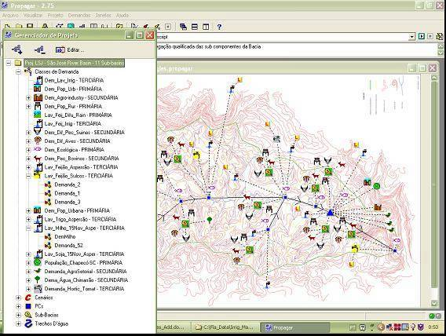
Fig. 3. Representation of the S. José River Basin with location of main water users, control points and reservoirs
Adopting the same procedure for irrigation demand as for the other uses was only possible after model integration (Fig.2). However, a different procedure is adopted: irrigation demand is represented by two type of objects, the “crop systems objects” (LAV, abbreviation of “lavoura” ), which define the crop-soil-climate unit and relevant agronomic practices required as input to ISAREG, and the “irrigation management objects” (MAN, abbreviation of the word “manejo”) associated to the first ones. For any irrigation demand location, some crop characteristics such as the planting and crop growth stages dates are considered in various alternatives for simulation because adjusting such dates to the rainfall regime may lead to reduce the crop irrigation demand. The simulations with ISAREG are performed with the LAV objects and respective results are stored in the corresponding MAN objects. Therefore, when alternative management scenarios are simulated the respective results may be compared and analyzed with MAN, where are also included economic results and water and land productivity indicators. This option allows to perform auxiliary data computation and building specific data bases that facilitate the selection of alternatives during the process of water allocation at the river scale.

3.2. Simulation procedures and scenarios
A form for editing data required for the simulation of alternative management scenarios with the object LAV is shown in Fig. 4. It concerns the command from the model PROPAGAR for the execution of the water balance with ISAREG when building the scenario AG 1.

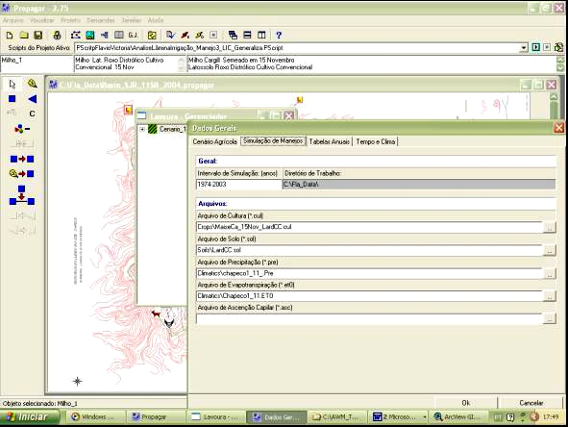

Fig. 4. Form of model PROPAGAR to edit data and irrigation thresholds to execute a water balance simulation with ISAREG relative to a selected irrigation scenario.
When an irrigation management scenario is simulated for a given object LAV, the respective relevant results are stored in the associated object MAN. When data sets are relative to a several years data set results refer to all those years as shown in the table in Fig. 5. a statistical analysis may then be performed to base the allocation decisions relative to a given probability of the demand. Prior to do so, the net irrigation requirements are converted into gross irrigation requirements through the average application efficiency assigned to the respective object LAV.
Because ISAREG is able to estimate the non-used fraction of rainfall and data in objects LAV refer to alternative planting dates for the crop under consideration, the simulations are performed for those different dates aiming at finding alternatives that maximize the use of rainfall and thus, minimize the irrigation demand.
To produce data for performing the input-output analysis at the control points, results from ISAREG simulations are summed up to the total area cropped. Allocation simulations with the PROPAGAR model are not only based on water volumes demanded but also on the economic results associated to the alternative scenarios such as gross margins, farm income and profit, as well as to performance indicators including water productivity and rainfall use productivity. All economic and physical results characterizing a scenario may be accessed through tables and forms similarly to those for irrigation requirements in Fig. 5. This facility enables the user to modify scenarios and to establish dialog with water users, particularly the farmers, in order to orient their practices into more performing water uses.

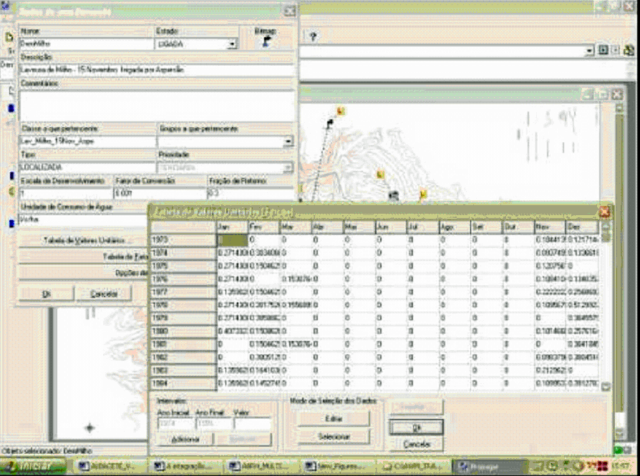

Fig. 5. Table with monthly gross irrigation requirements relative to several years climate data referring to an object LAV (maize), and editing form relative to the respective object MAN
3.3. Water demand and allocation
After performing the analysis referring to the irrigation scenarios as described above, the irrigation management options are selected relative to every LAV objects in the basin. The gross irrigation demands are summed to the areas cropped and the respective demand hydrographs are built.
Results from the aggregation of the irrigation demand to the sub-basin and the year level with PROPAGAR are shown in Fig. 6 and 7. The first is relative to beans and soybeans at the sub-basin Faxinal das Rosas, and the second concerns wheat and maize in the sub-basin Cordilheira Alta. The peak demand occurs at different time periods in both locations. These examples show that adopting different crop patterns (and different planting dates for some crops) leads to lowering the total irrigation peak demand by creating various peaks along the year, which are more easy to be satisfied by pumping directly from the watercourses, as it is the case in S. José basin.
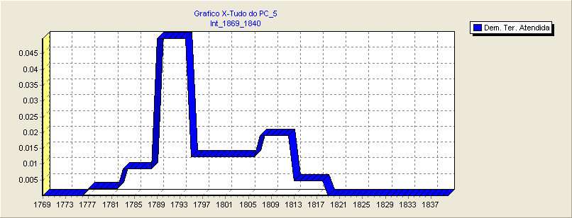
Fig. 6. Gross irrigation requirements (m3/s) for (57 ha) beans planted 15 Sept. and (96 ha) soybeans planted 15 Nov. at the sub-basin Faxinal dos Rosas (07/1998 to 07/1999, sprinkler irrigation, irrigation aiming at maximal yield). FLÁVIO, O EIXO DOS YY NECESSITA DAS UNIDADES E O DOS XX DE POR DATAS OU DE ESCLARECER O QUE SÃO OS NÚMEROS

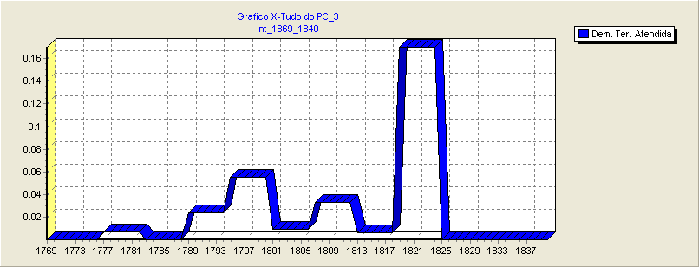
Fig. 7. Gross irrigation requirements (m3/s) for (68 ha) wheat planted 15 July and (312 ha) maize planted 15 Nov. at the sub-basin Cordilheira Alta relative to the period 07/1998 to 07/1999, sprinkler irrigation, and irrigation aiming at maximal yield. FLÁVIO, O EIXO DOS YY NECESSITA DAS UNIDADES E O DOS XX DE POR DATAS OU DE ESCLARECER O QUE SÃO OS NÚMEROS
The irrigation demand hydrographs are then considered together with those relative to all other uses at each control point along the basin and the input-output balance is performed. It results a decision on full or partial satisfaction of the demands. Demand for irrigation in the case study basin is of lower priority relative to other uses because demand for irrigation started recently relative to the other customary uses. The analysis of failures to satisfy the demand is performed through simulation tables as in Fig. 8 where ecological, urban and industrial, and irrigation demands are analyzed in separate.
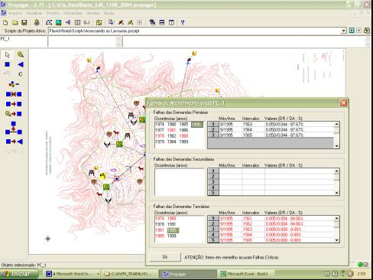
Fig. 8. Table for analysis of failures in satisfaction of demand: case for the upstream control point PC 1 with identification of failure periods relative to ecological, urban and industrial, and irrigation demand, respectively on top, mid and low tables
In Fig. 9 relative to the control point PC 3 are presented the results of the balance demand vs. supply relative to irrigation simulated for 1991, showing that the demand could be satisfied for only near 50% during December. Another example is given in Fig. 10 relative to the upstream control point PC 1 (Fig. 10) where, for the period 06/1995 - 12/1995, both the ecological discharges and the irrigation demand cannot be fully satisfied for some time in September: 87,7% satisfaction for the ecological discharges but nothing at all for irrigation.
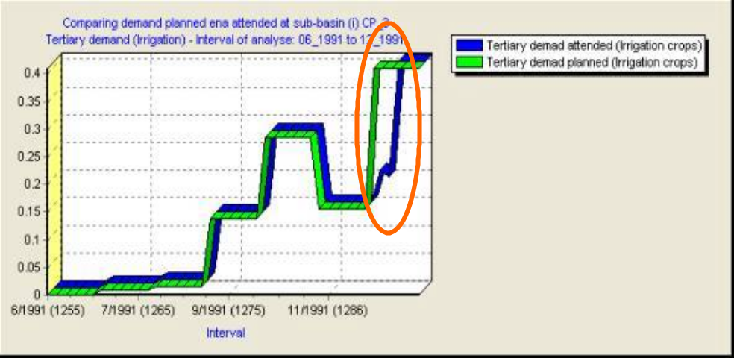
Fig. 9. Comparison of the irrigation demand with the planned supply at the control point PC 3 showing that river water availability was insufficient to satisfy the demand for about 50% in December.
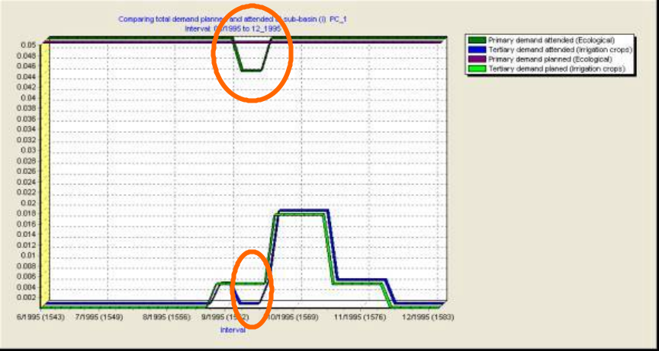

Fig. 10. Identification of periods when demand is not satisfied at PC 1for the period 06/1995 to 12/1995: above for the ecological discharges and below relative to irrigation.
When failure periods are predicted from the PROPAGAR simulations, the irrigation management options may be revised and different crop planting dates or crop patterns may be proposed to the farmers where the probability for satisfaction be adequate. Otherwise, a reduction of the irrigated area may be considered for that area in the basin. Similarly, possible reductions in the demand for other uses may be simulated and proposed. In the present version, the model is running through successive iterations to search the water management solutions that produce the more beneficial water use in the basin. Using this iterative approach, the model is also able to simulate the impacts of storage and regulation reservoirs in the prevision that demands increase for some activities and given areas within the basin. Adopting an iterative simulation approach supports a better dialog with users in searching improved water use options, particularly with farmers after the multi-scale integration has been implemented. From the management point of view, this approach also allows to understand how a water price policy affects water use since the economic factors relative to agricultural production are made available for analysis. The approach presented herein shows to be adequate to deal with both basin and field space scales of simulation. However further improvements may be required to refine the already implemented water use and economic analysis tools to better assess the inputs of water use restrictions.
4. CONCLUSIONS
Multi-scale modeling integrating the field scale irrigation scheduling simulation model ISAREG with the basin scale water management and allocation model PROPAGAR has been successfully adopted to the S. José River Basin, S. Catarina, Brazil. Integration was facilitated by the fact that the basin scale model uses object-oriented programming tools and the field scale model may be associated to selected objects when these are appropriately characterized with input data for the simulation.
This allows simulating the irrigation demand in a realistic way and comparing the actual demand with alternative options that adopt improved technologies and management, which help to accommodate to the prevailing environmental conditions, or that consider alternative planting dates and deficit irrigation aiming at maximizing the use of rainfall and to decrease the peak demand. Alternative scenarios for both irrigation and river water availability and allocation may then be simulated to produce information useful for farmers, managers and other users about measures and practices that lead to better matching demand and supply at the river basin.
The simulations at field level allow to consider differences in crop and irrigation technologies and to analyze the economic impacts of irrigation alternatives at farm level. The economic analysis tools implemented also allow to assess the impacts of river allocation policies and water prices on the farm incomes. Therefore, using iteratively both the field and basin scale models it is possible to find solutions that accommodate better the water management and the agricultural decisions.
The integration approach adopted allows analyzing impacts of irrigation demand on other uses within the basin. It shall also help solving conflicts among users but for that purpose the model has to be improved with the adoption of appropriate economic and social analysis tools specific for the non-irrigation water uses. Such implementation is underway and may also be useful for training and to educate the users to achieve higher water use performances, as well as about interactions among users, thus helping the society in better managing its water particularly during periods when it is scarce.

5. REFERENCES
Alba, I., P.N. Rodrigues, L.S. Pereira, 2003. Irrigation scheduling simulation for citrus in Sicily to cope with water scarcity. In: G. Rossi, A. Cancelliere, L. S. Pereira, T. Oweis, M. Shatanawi, A. Zairi (Eds.) Tools for Drought Mitigation in Mediterranean Regions. Kluwer, Dordrecht, pp. 223-242.
Allen R.G., Pereira L.S., Raes D., Smith M., (1998), Crop Evapotranspiration Guidelines for Computing Crop Water Requirements. FAO Irrig. Drain. Paper 56, FAO, Rome, 300 p.
CGIAR, (2002), CGIAR Challenge Program on Water and Food—Revised Full Proposal, CGIAR and IWMI, Colombo, 142 p.
FAO, (2002), Crops and Drops – Making Best Use of Water for Agriculture. FAO, Rome, 23p.
Fortes P.S., Platonov A.E., Pereira L.S. (2004), GISAREG - A GIS based irrigation scheduling simulation model to support improved water use and environmental control. Agric. Water Manage. (This issue).
Gonçalves JM, Pereira LS, Campos AA, Fabião MS, Paredes P, Fang SX, Mao Z, Dong B, (2002), Modeling demand and distribution for environmental upgrading of the Huinong irrigation system, upper Yellow River Basin: a multi-criteria approach for DSS in the irrigation domain. In: 2002 ASAE Annual International Meeting / CIGR XVth World Congress (Chicago, Illinois, July 28-July 31, 2002) ASAE, CD-ROM paper 022211.
Lanna A.E., (1997a), SAGBAH - Sistema de Apoio ao Gerenciamento de Bacias Hidrográficas - Versão 97. IPH-UFRGS, Porto Alegre.
Lanna A.E, (1997b), Modelos de gerenciamento das águas. A Água em Revista 5(8): 24-33.
Liu Y., Teixeira J.L., Zhang H.J., Pereira L.S., (1998), Model validation and crop coefficients for irrigation scheduling in the North China Plain. Agric. Water Manage. 36: 233-246.
Molden D., Amarasinghe U.A., Hussain, I., (2001), Water for Rural Development. IWMI paper 32, IWMI, Colombo, 90p.
Pereira L.S., (2003), Performance issues and challenges for improving water use and productivity. In: T Hata and A H Abdelhadi (Eds.) Participatory Management of Irrigation Systems, Water Utilization Techniques and Hydrology (Proc. Int. Workshop, The 3rd World Water Forum, Kyoto), Water Environment Lab., Kobe University, pp. 1-17.
Pereira L.S., Cordery I., Iacovides I., (2002a), Coping with Water Scarcity. UNESCO IHP VI, Technical Documents in Hydrology No. 58, UNESCO, Paris, 267 p.

Pereira L.S., Oweis T., Zairi A., (2002b), Irrigation management under water scarcity. Agric. Water Manage. 57: 175-206.
Pereira L.S., Teodoro P.R., Rodrigues P.N., Teixeira J.L, (2003), Irrigation scheduling simulation: the model ISAREG. In: G Rossi, A Cancelliere, LS Pereira, T Oweis, M Shatanawi, A Zairi (Eds.) Tools for Drought Mitigation in Mediterranean Regions. Kluwer, Dordrecht, pp. 161-180.
Perry C.J., Narayanamurthy S.G., (1998), Farmer response to rationed and uncertain irrigation supplies. IWMI Research Report 24. Colombo, Sri Lanka.
Pilar J.V., Lanna A.E., (1999), Planejamento por otimização linear de um sistema de recursos hídricos sem regularização: bacia do rio Paracatú. Rev. Brasil. Recursos Hídricos 4(2): 61-72.
Rodrigues, P.N., T. Machado, L.S. Pereira, J.L. Teixeira, H. El Amami, A. Zairi, 2003. Feasibility of deficit irrigation with center-pivot to cope with limited water supplies in Alentejo, Portugal. In: G. Rossi, A. Cancelliere, L. S. Pereira, T. Oweis, M. Shatanawi, A. Zairi (Eds.) Tools for Drought Mitigation in Mediterranean Regions. Kluwer, Dordrecht, pp. 203-222.
Rosegrand M.W., Cai X., Cline S., Nakagawa N., (2001), The role of rainfed agriculture in the future of global production, Background Paper to the International Conference on Freshwater, GDI/IFPRI, Bonn, 65p.
Seckler D., Amarasinghe U., Molden D., Silva R., Barker R., (1998), World Water Demand and Supply, 1990 to 2025: Scenarios and Issues. IWMI Res. Rep. 19. Colombo, 40p.
Strzepek K., Molden D., Galbraith H., (2001), Comprehensive global assessment of costs benefits and future directions of irrigated agriculture. Dialogue on Water, Food and Environment. IWMI Working Paper 3. Colombo.
Teixeira J.L., Pereira L.S., (1992), ISAREG – An irrigation scheduling model. ICID Bulletin 41 (2): 29-48.
The World Bank, 2003. Sustainable Development in a Dynamic World. Transforming Institutions, Growth, and Quality of Life. World Development Report 2003, The World Bank and Oxford University Press, Washington, DC, and New York. 272 p
UNEP, 2002. Global Environmental Outlook 3. Past, Present and Future Perspectives. UNEP and Earthscan, London, 426p.
Victoria F.R.B., (1998), Irregularidade na distribuição das chuvas e o ciclo das culturas. In: Reunião Técnica Catarinense de Milho e Feijão. EPAGRI, Chapecó, pp. 57–60.
Victoria F.R.B., Teixeira J.L., (2001), Integrated tools to mitigate effects of climatic adversities. In: AA Soares and HM Saturnino (eds) Competitive Use and Conservation Strategies for Water and Natural Resources (Proc. 4th. Inter-Regional Conf. on Environment and the Water, Fortaleza, Brazil), ABID, Brasília, pp. 46-55.
Viegas Filho J.S., (2000), O paradigma da modelagem orientada a objetos aplicado a sistemas de apoio à decisão em sistemas de recursos hídricos. PhD Thesis, IPH-UFRGS, Porto Alegre.
Viegas Filho J.S., Lanna A.E., (1999), A modelagem orientada a objetos aplicada a sistemas de apoio a decisão em recursos hídricos. In: Anais do XIII Simpósio Brasileiro de Recursos Hídricos, Assoc. Brasil. Recursos Hídricos, Porto Alegre.
Zairi, A., H. El Amami, A. Slatni, L.S. Pereira, P.N. Rodrigues, T. Machado, 2003. Coping with drought: deficit irrigation strategies for cereals and field horticultural crops in Central Tunisia. In: G. Rossi, A. Cancelliere, L. S. Pereira, T. Oweis, M. Shatanawi, A. Zairi (Eds.) Tools for Drought Mitigation in Mediterranean Regions. Kluwer, Dordrecht, pp. 181-201.

Researcher at Agricultural Engineering Research Center, Institute of Agronomy, Technical University of Lisbon, Portugal, and CEPAF / EPAGRI, S. Catarina-Brazil, (fvictoria@isa.utl.pt).
Professor, Federal University of Pelotas, Pelotas, Rio Grande do Sul, Brazil (jsviegas@uol.com.br)
Professor, Agricultural Engineering Research Center, Institute of Agronomy, Technical University of Lisbon, Portugal (lspereira@isa.utl.pt and jlteixeira@isa.utl.pt).
Professor, Federal University of Rio Grande do Sul, Porto Alegre, Brazil (lanna@uol.com.br)

